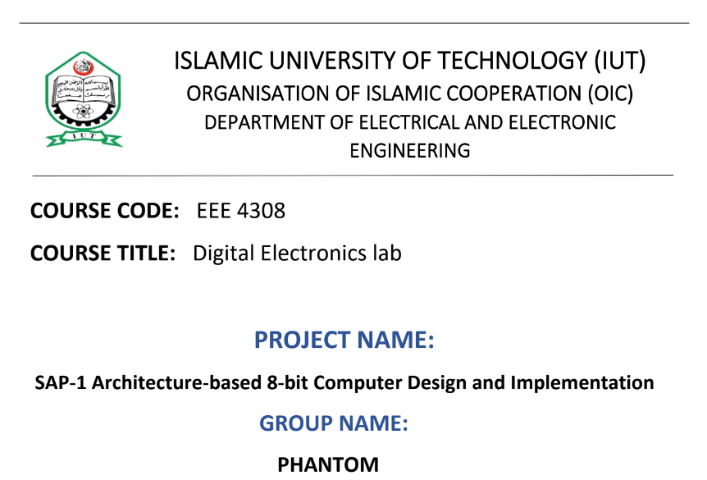

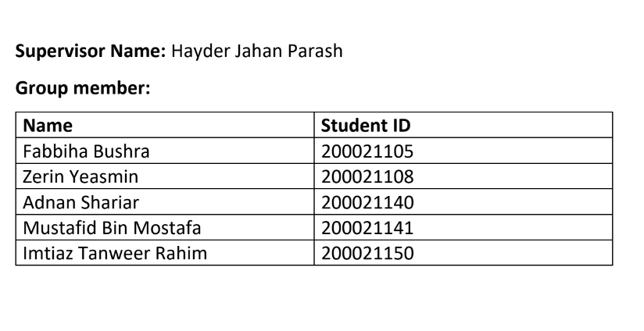

# Objective:

The project's goal is to build an 8-bit computer based on the SAP-1 (Simple-As-Possible)

architecture combining combinational and sequential circuits.

# SAP-1:

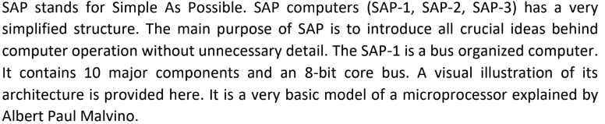

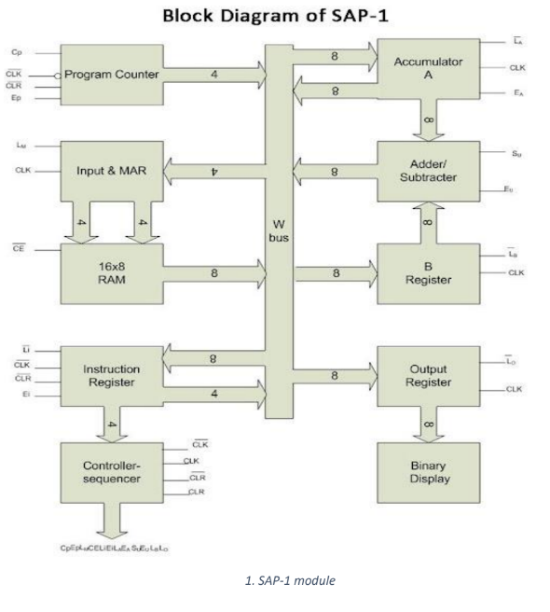

# 1.Clock Pulse Generator:

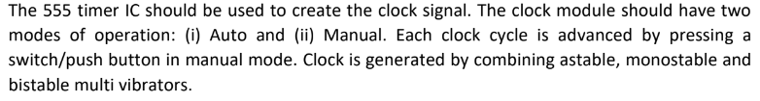

## Software simulation:

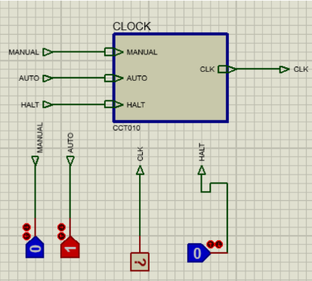

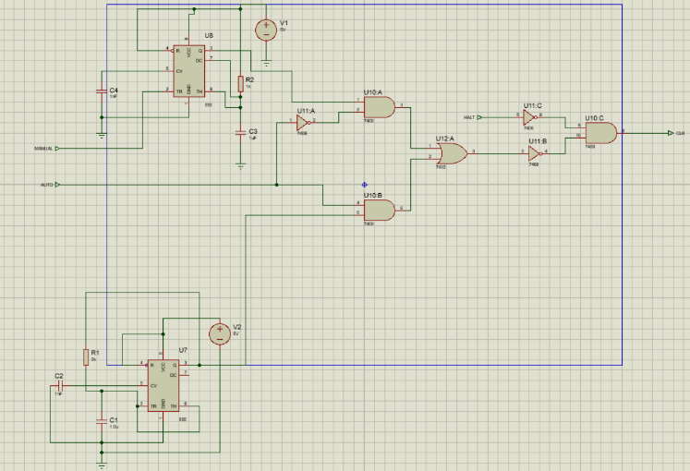

## Hardware implementation (PCB):

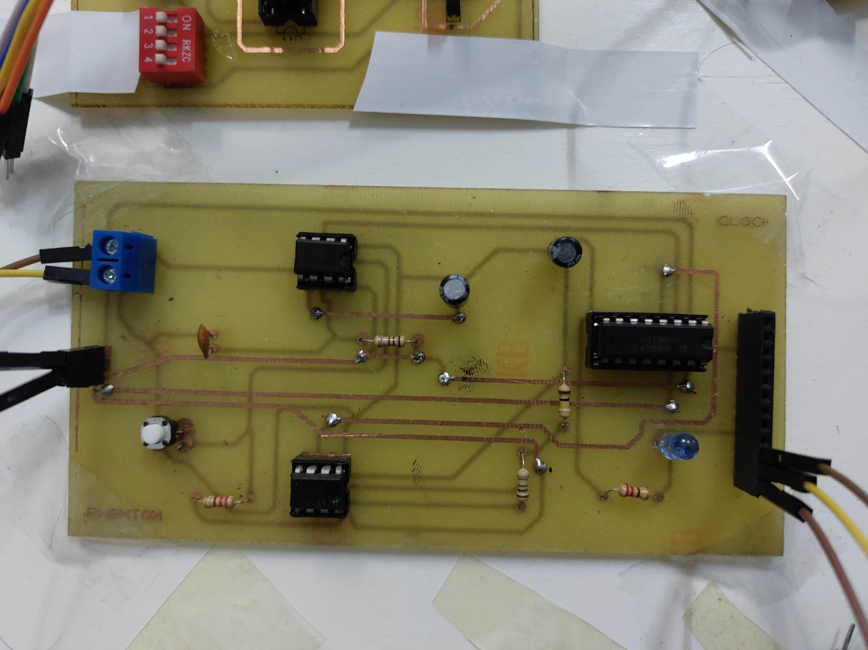

# 2.Program Counter:

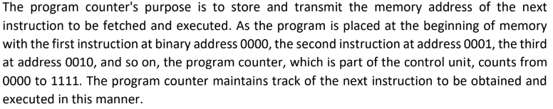

## Software simulation:

